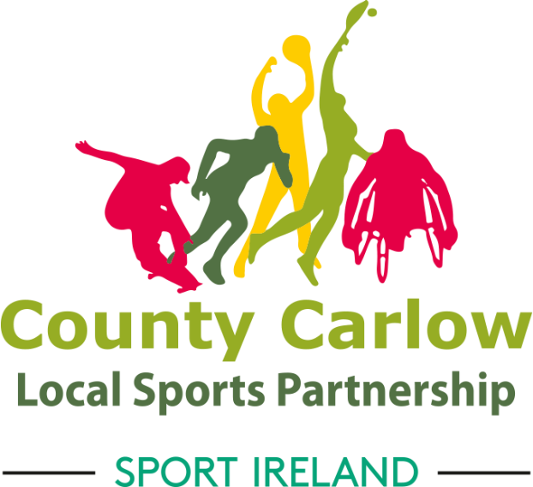
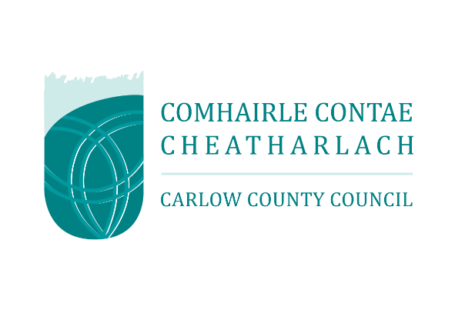

Clubmen on the Move Application Form

Application Form: "Clubmen on the Move" Initiative
- Objective: The program aims to facilitate fitness programs within clubs specifically tailored for adult male members to promote physical activity, well-being, and social engagement.
- Eligibility: Open to all clubs within Carlow interested in engaging their male members in structured fitness activities.
- Application Process:
  - Clubs interested in participating must submit a completed Application Form to Carlow Sports Partnership.
  - Applications will be reviewed, and selected clubs will be notified of their acceptance into the program.
- Program Funding:
  - Carlow Sports Partnership will provide financial support up to a maximum amount of €600 per club.
  - Funding can be utilised for qualified club members or external professionals to lead the fitness programs, equipment purchase, venue costs, etc.
  - Funding disbursement will be subject to the approval of the proposed program outlined in the application.
- Program Implementation:
  - Participating clubs will be responsible for designing and executing fitness programs tailored to their members' interests and preferences.
  - Carlow Sports Partnership will offer organisational support, guidance, and necessary training to facilitate the successful implementation of the programs.
- Reporting and Evaluation:
  - Clubs will be required to submit periodic progress reports detailing the implementation and outcomes of the fitness programs and images of participants taking part in the program.
  - Carlow Sports Partnership may conduct periodic evaluations to assess the program's impact and effectiveness.

Club Information:
- Club Name:
- Contact Person:
- Role in the Club:
- Contact Email:
- Contact Phone Number:
- Club Address:

Program Details:
- Description of the Program: (Include details about the type of activities, frequency, duration, target participants, etc.)
- Location(s) for the Program:
- Estimated Number of Participants:
- Do you have a qualified club member to lead the program? (Yes/No)
If yes, please provide their details:

- Would you require an external professional to lead the program? (Yes/No)
Declaration:
By submitting this application, we affirm that the information provided is accurate and that we agree to comply with the guidelines and objectives of the "Club Men on the Move" initiative.
Signed: Date:

