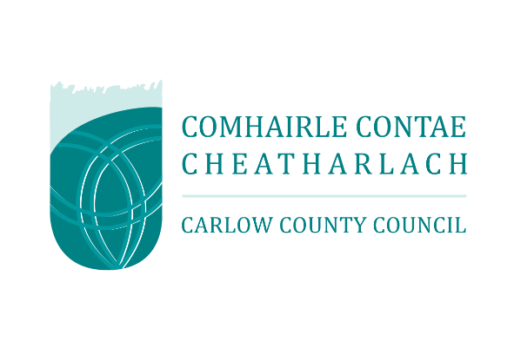
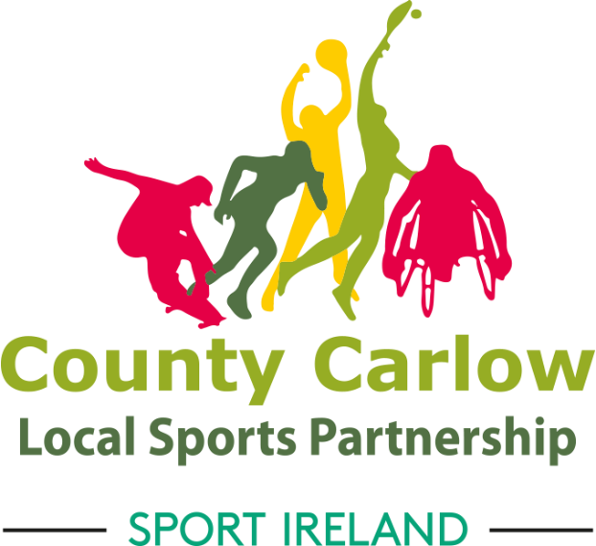

Please Note: Only one application will be accepted per club/group/organisation and the grant application must be signed by the Chairperson of the club plus one other committee member.

Local Sports Participation Grant Scheme Guidelines & Application Form 2023
Closing date: 5:00pm Friday 8th December 2023

Local Sports Participation Small Grants Scheme
Application Guidelines 2023

Background
Carlow Sports Partnership has secured funding from Sport Ireland to support the development of sport and physical activity in County Carlow with a particular emphasis on low participation groups such as young people, people with a disability, older adults, women and girls, ethnic minorities and people residing in disadvantaged areas.
This grant scheme is one element of a range of supports offered by Carlow Sports Partnership, and available to local clubs and physical activity groups, for various reasons including: Training & Capacity Building; Volunteer Development; Funding Guidance; Programme Development; Facility Development; School/Club Links & Sports Club/NBG Directories, etc. The Local Sports Participation Small Grant Scheme 2023 is to fund initiatives that increase participation of the following target groups. These groups have been identified through national research reports as having low participation rates:

Overall Aim
This fund aims to assist existing clubs and community groups that have physical activity and sport as their primary activity and encourage the set-up of new clubs and groups to promote physical activity and sport. The National Sports Policy 2018 – 2027 highlights the need to prioritise support for minority sports and low participation groups including young people, females, people with a disability, ethnic minorities, older adults and clubs/groups located in disadvantaged areas.
Read more here: https://assets.gov.ie/15979/04e0f52cee5f47ee9c01003cf559e98d.pdf

How Much Funding is Available?
The maximum grant available is €2,000. Please note that capital projects are not eligible under this grant scheme. This is a competitive fund. Evidence of match funding and/or benefit in kind will increase the chance of success for an application.

Who Can Apply?
Grants are available to all local sports clubs, community groups, and voluntary organisations that promote physical activity & sport. This grant is not available to schools, contact the Sports Partnership office for information on school supports.

To be eligible, organisations/clubs/groups must:
- Operate as a ‘not for profit’ club or group that is open to public membership
- Be based in County Carlow and have an objective relating to physical activity
- Submit a proposal to increase participation of a particular target group
- Operate under the basis of best practice for children in sport and show evidence of club representative(s) completion of Safeguarding Children Basic Awareness
- Submit only one application per organisation/club/group.

The following individuals/organisations are not eligible to apply:
- National/Regional/County governing bodies, excluding Community Games
- For profit groups/commercial organisations/private facility owners
- Statutory agencies and schools
- Projects funded through another source, e.g., Sports Capital Grant Scheme

Key Criteria for Assessment
The grant applications will be assessed by the Carlow Sports Partnership Advisory Committee, which is a sub-committee of Carlow County Council. If the application is not completed in full it will not be assessed further and will be deemed ineligible. The decision of the Carlow Sports Partnership Advisory Committee is final. The assessment of applications will be based on the criteria outlined below:
- Only fully completed application forms will be considered
- Quotes attached to application form
- Description of activities that have the potential to increase participation in physical activity
  - Priority will be given to initiatives that aim to increase participation and inclusion of ethnic minorities, people with a disability, women and girls, older adults and people residing in disadvantaged areas
- Explanation of how success will be measured
- Commitment of any match funding/benefit-in-kind

Examples of Eligible Costs:
- Initiatives/events/programmes that will attract new participants
- Tutor/coach costs (if external to the normal running of club activities)
- Introduction of new activities/sports
- Programmes to enhance club relations with schools
- Establishing a new competition/recreational outlet
- Equipment costs
- Activities that promote social inclusion amongst groups with low participation
- Couch to 5km, community fitness programmes, etc.

Examples of Ineligible Costs:
- Capital Projects (e.g., pitch development etc.)
- Costs, including wages, associated with the administration of this grant
- Costs associated with travel to competitions
- Ongoing operational costs such as rent, insurance, membership fees, etc.
- Clothing – individual or team kits
- Coaching/instructing salaries & wages of a continual or seasonal nature

Evaluation Report Form
Applicants should note that the successful organisations/clubs/groups will be required to complete a short evaluation report form on completion of the funded activity.

Applications
- Applications should be signed by two organisations/clubs/groups committee members (the chairperson and one other member).
- Only one application will be accepted per organisations/clubs/groups and the signatory must be the chairperson of the club, not of sub-sections or sub-committees.
- Quotations must be included with the application.
- Virtual completed applications, including required signatures, will be accepted via a scanned PDF which should be sent to Ger, via gbonner@carlowcoco.ie
- Hard copies of completed applications will also be accepted and should be sent to: Carlow Sports Partnership, Carlow Town Hall, Centaur Street, Carlow. R93 TK85.
The closing date for receipt of applications is
5:00pm Friday 8th December 2023.
Applications received after this date will not be considered.

This grant scheme is supported by Carlow County Council and Sport Ireland. For further information please contact the Carlow Sports Partnership office on 0599172412 or gbonner@carlowcoco.ie

Application Form

Section One: Club/Group/Organisation General Profile

Applicant Details
Name of Group
Address
Website
Chairperson
Secretary
Treasurer

Details of contact person for the club/group/organisation to be listed on Carlow Sports Partnership’s website
Name
Position in Group
Phone Number
Email

Club/Group/Organisation Bank Account Details
Name of Bank
Address of Bank
Account Name
IBAN
BIC

Please note that all payments will be processed directly to the club/group/organisation Bank/Building Society Account only via Carlow County Council.

Affiliation
- Is your club/group/organisation affiliated to a National Governing Body of Sport (NGB)?
Yes No

- If yes, please state the name of the NGB:
- Is your club/group/organisation a member of the Public Participation Network?
Yes No

Club/Group/Organisation Membership Details
Please complete the table below with the participation number of your club/group/organisation
Age Group | Male | Female | Gender Neutral | Person with a Disability
12 years and under
13 – 18 years
19 – 45 years
46+ years
Total
Combined Total

Section 2: About the Club/Group/Organisation
(Please add additional sheets where necessary)

Please describe the purpose of your club/group/organisation and specify the sports/physical activities that you provide for members:

Child Protection
- Does your club have a child protection Policy?

Yes No

- Has a representative from your club/group/organisation attended a certified Child Safeguarding Awareness Course?

Yes No

- If yes, what is the name of the rep(s) and the number(s) on their cert(s)?

Please outline any training that you or members of your club/group/organisation would like to see Carlow Sports Partnership providing. Examples include, but are not limited to:

- Communications
- Poster Design
- Social Media
- Committee Roles
- Governance
- Minute Taking
- Grant Application
- Coaching Teenage Girls
- Sport Specific Coaching
- Increased volume of existing training opportunities

Section 3: Use of Small Grant Scheme Funding

Please specify which target group(s) you will be organising activities for:
Target Group | Please Tick
Youth
Older Adults
Women & Girls
People with a Disability
Ethnic Minorities
Local Community
(not current members)

Please outline the following areas of how your club/group/organisation intends to use the grant funding. Additional sheets may be added if necessary:
Description of the Activity:
Why did you choose the above target group(s) and how will the activity(activities) planned increase the participation of this group?

What is the proposed duration and frequency of the activity?

What is the estimated number of people who will participate in the activity?

Who will deliver the activity? (Club coaches, external coaches, fitness instructors, Carlow Sports Partnership tutors etc.,)

What are the resources needed and what resources can the club/group/organisation provide?

How will you promote the activity and encourage the Target Group(s) to attend?
How will you measure the success of the activity?

What are the associated costs?
(Please give a full breakdown of itemised costs and please attach supporting quotations, reminder the maximum amount to be applied for is €2,000.00).
Cost Area | Amount
Total

Are there any costs that can be covered through your club/group/organisation either through funding or benefit-in-kind?

Cost Area | Amount
Total

Section 4: Declaration
I have read and understand the guidelines and criteria and I declare that the information supplied on this application form is complete, correct, and accurate in every respect. This application form must be signed by two people: The Chairperson of the committee and one other member of the club/group/organisation’s committee.

First Signature
Signed:
(On behalf of the club/group/organisation)
Name:
(Block Capitals)
Position:
Date:

Second Signature
Signed:
(On behalf of the club/group/organisation)
Name:
(Block Capitals)
Position:
Date:

Section 5: GDPR
Application Details: The information collected in this application will be used only for the purpose of this grant scheme. This information will not be shared with any third parties. We will retain this information for 5 years and then it will be deleted.
Contact Details: With regard to your contact details only, do you give your consent for Carlow Sports Partnership to retain your club/group/organisation contact details to add to a web-based Carlow Club & Physical Activity Group Directory?
Yes No

Section 6: Confirmation

Declaration | Please Tick
I declare that I have reviewed and approved the above application form and that the information given in this funding application is true and accurate and have attached all quotations for monies being applied for.
I understand that by applying for this funding my club/group/organisation agrees to submit and comply with any audit or inspection as may be required to assert the accuracy of the application and the expenditure of any allocated funds.
I have read and understood the Terms and Conditions of Grants. On behalf of my organization I accept the terms and conditions of grants and agree to be bound by these terms and conditions.
I hereby apply for grant-aid for the for club/group/organisation 2022.
My club/group/organisation would like to be added to the Carlow Sports Partnership database.
I would like my email address to be added to the Carlow Sports Partnership email list.

Section 7: Completed Application Forms

Virtual completed applications, including required signatures, will be accepted via a scanned PDF which should be sent to:
gbonner@carlowcoco.ie

Hard copies of completed applications will also be accepted and should be sent to:
Carlow Sports Partnership,
Carlow Town Hall,
Centaur Street,
Carlow.
R93TK85

The closing date for receipt of applications is
5:00pm Friday 8th December 2023.

Applications received after this date will not be considered.

This grant scheme is supported by Carlow County Council and Sport Ireland. For further information please contact the Carlow Sports Partnership office on 0599172412 or gbonner@carlowcoco.ie

