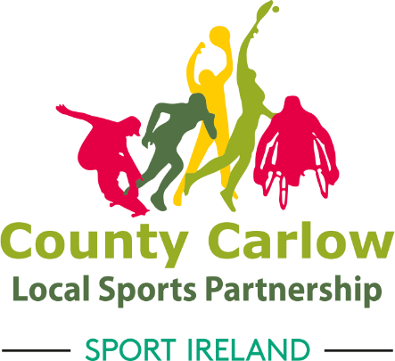
Expression of Interest Form

Please provide the following information:

1. Applicant details

Name of Club, Group or Organisation you are currently involved with
Name
Address
Phone
Email

2. Which of the following objectives for the Bagenalstown Activity Hub are you most interested in assisting
Securing Funding Streams
Sharing Information (emailing, posters, social media, community notes, radio)
Support and Encouraging Clubs, Groups, and Organisations to get involved with the Bagenalstown Activity Hub
Training (engaging with training providers to deliver training to identified groups)
Programmes (assisting in organising, and overseeing taster sessions, events etc.,)
All the of the above

3. Please describe any past committee experience you may have and/or what you feel you can contribute to the Bagenalstown Activity Hub subcommittee?

Signed: _________________________________________
Date: _________________________________________

