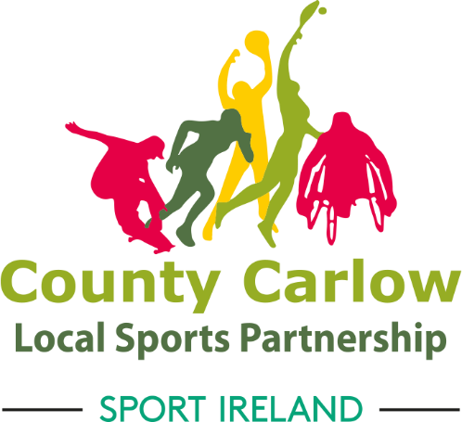
Bagenalstown Activity Hub Sub-Committee Recruitment
Carlow Sports Partnership are seeking expressions of interest from members of the Bagenalstown community and surrounding areas to join the Bagenalstown Activity Hub Sub-Committee.

Background
The key aims of the Bagenalstown Activity Hub are to ensure that local resources are used to best effect. With the vision of creating long-term sustainability and a legacy from 5-year hub dormant account funding via Sport Ireland. The hub will operate within the existing structures of Carlow Sports Partnership. The Activity Hub objectives are to provide:
- Funding
- Information
- Support
- Training
- Programmes

Duties

The remit of the proposed subcommittee will be to oversee the development of the Activity Hub plan. To support the Hub Coordinator in promoting and developing an Activity Hub for the community and Municipal District and to increase levels of participation in sport and physical activity through existing community groups, schools, clubs, and organisations in and around Bagenalstown.

The sub-committee will aim to bring Bagenalstown representatives together and draw on their individual expertise, independence, and diversity in line with the objectives of the Community Sports & Physical Activity Hub.
The subcommittee will meet once a month online or in person where possible. The agenda will be set prior to each meeting and sent to the subcommittee. Please note that no meeting will take place in July & August.

Structure
The Bagenalstown Activity Hub subcommittee will be overseen by the current Bagenalstown Steering Group which comprise of the following members: John Murphy, Paddy Gardiner, Colin Rea, Keara O’ Dea & Carol Clarke. Furthermore, Carol Clarke will act as a representative from the main steering group and will sit on the Hub subcommittee.
On a wide range of sports and physical activities to make it easier for people to get involved and engage in a more active and healthier lifestyle in Bagenalstown.

Application
If you are interested in becoming a member of the Bagenalstown Activity Hub, please complete the Expression of Interest form.
Please note that the closing date for the receipt of expressions of interest is Friday 28th January 2022. Applications received after this date will not be considered.
If you have any queries or require further information, contact Majella Fennelly on 087 9185466 or via mfennelly@carlowcoco.ie

